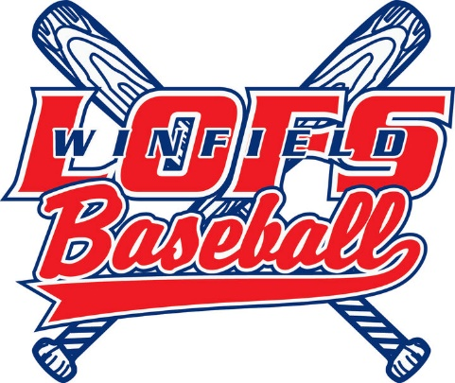
2018 Sponsorship
Thank you for sponsoring the Lakes of the Four Seasons / Winfield Little for the 2018 season! Your generosity and support will not only help make the 2018 season a success but will also allow the league to continue to improve our equipment and facilities for future generations.
Please complete the information below and return along with payment to the address below.

SPONSOR INFORMATION
Sponsor Name:
Contact: |  | Phone:
Email: |  | Website:

SPONSORSHIP PACKAGES
Individual: $50+ |  | Team Sponsor: $250
Returning Banner Sponsor: $75 |  | Team Sponsor w/Banner: $350
Banner Sponsor: $125 |  | Grand Slam: $550
 |  |  | TOTAL:

Please make checks payable to LOFS Little League. Payment and completed forms can be mailed to LOFS / Winfield Little League at:
LOFS / Winfield Little League
Attn: Richelle Aubin
656 Windy Oak Circle
Hebron, IN 46341-9773

